**LAB PROGRAM 1(BINARY SEARCH)**

**TRISHA LAKHANI**

**1BM19CS214**

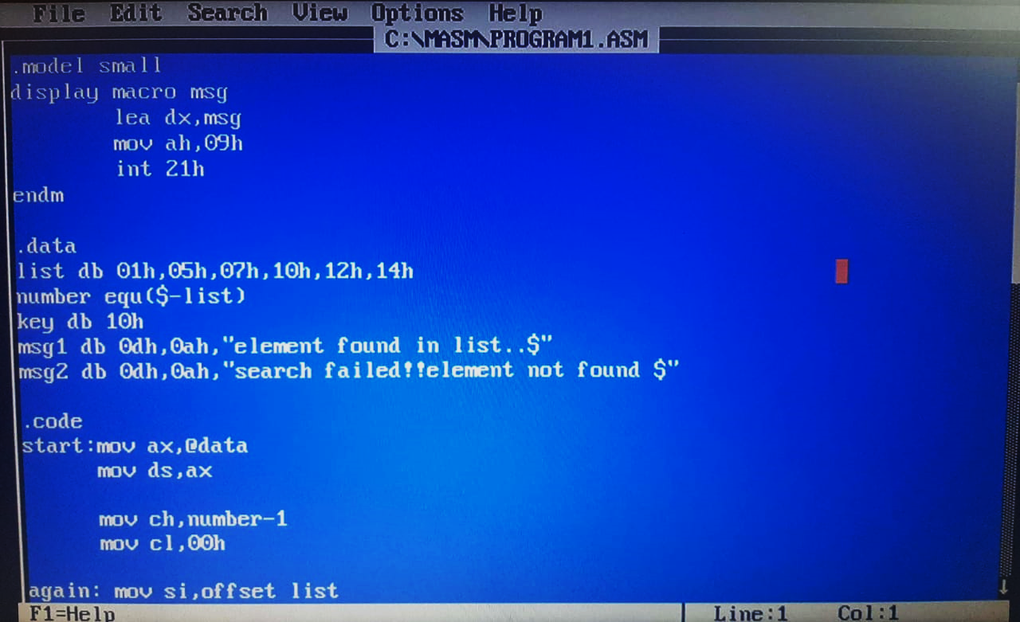

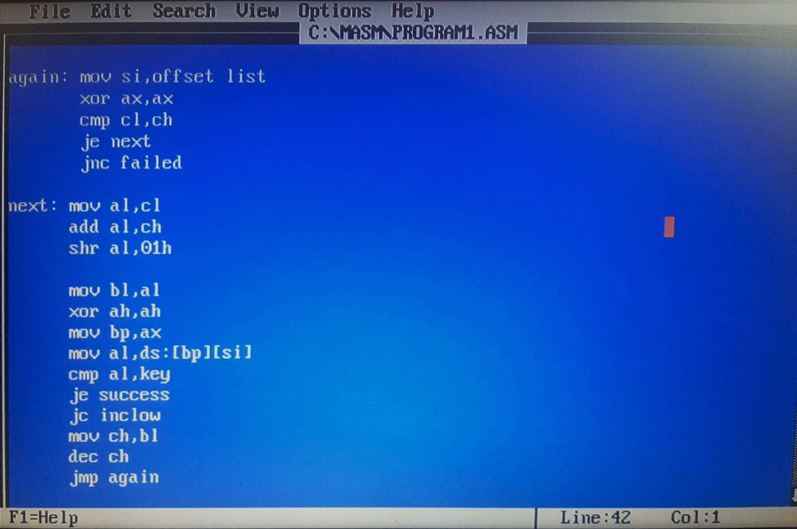

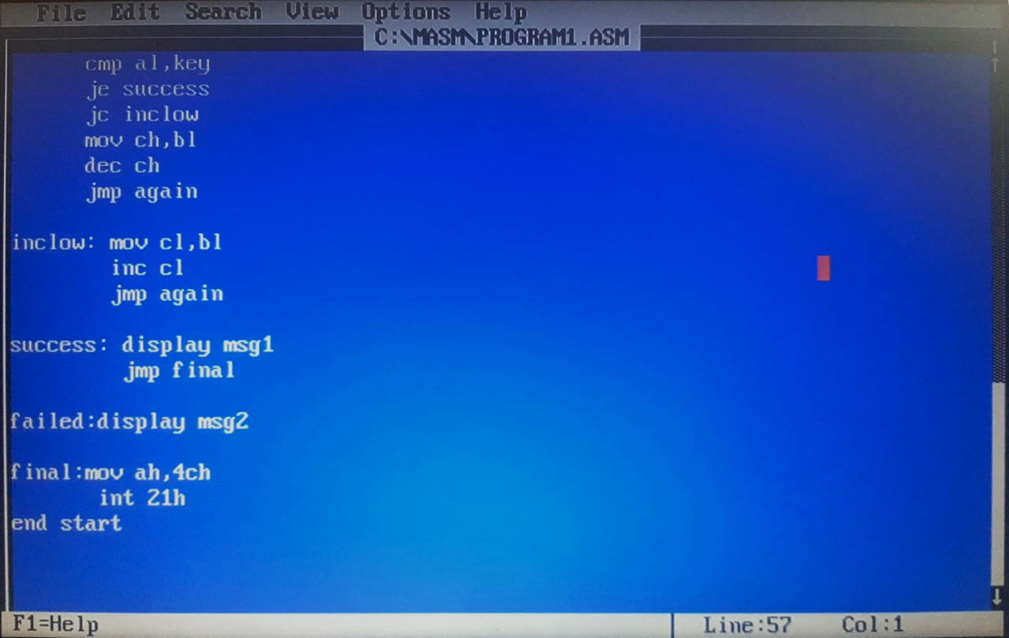

**OUTPUT**

